**Modern World History Final Exam Study Guide**

**Maps:**

Identify “major” countries in Asia, **Middle East*,*** North Africa, & Europe

What world events would you associate with these countries/areas?

China (Mao), North Africa (WW2 Battle), Germany (Bismarck)

Geographic significance and location: the Suez Canal (Egypt)

**Scientific Revolution:**

Definition/Basic Concepts

SR connection to the Church

Connection to the Enlightenment

**The Enlightenment:**

Definition/Basic Concepts

What is Autocratic rule?

Connect the Enlightenment to the French Revolution & the *Declaration of the Rights of Man and of the Citizen*

Connect the Enlightenment to the U.S. *Declaration of Independence*

Key Document: *Two Treatises on Government* (Locke)

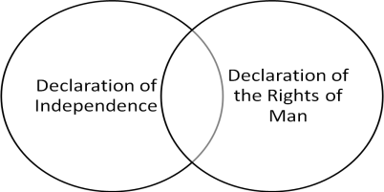

**French** **Revolution:**

Definition/Basic Concepts

What individuals/groups of individuals would you associate with the F.R.?

Connect the F.R. to the rise of Napoleon

Key Event: Reign of Terror; Napoleon; Napoleonic Code; Congress of Vienna

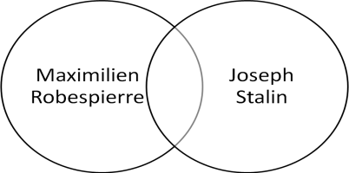

**Industrial Revolution:**

Definition/Basic Concepts

What individuals/groups of individuals would you associate with the I.R.?

Key Concepts: The Factors of Production, Communism, Capitalism

Key Documents: *The Communist Manifesto* & *The Wealth of Nations*

**Imperialism (and Nationalism):**

Definition/Basic Concepts

What individuals/groups of individuals would you associate with the Imperialism?

Identify motives and methods of European imperialism

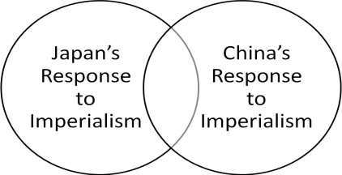Key Event: The Berlin Conference

Key Concept: Social Darwinism

Key Document: *The White Man’s Burden*

**World War I:**

Identify the causes of WWI

New technology/weapons introduced during the war

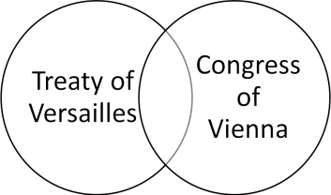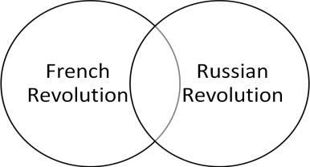Key Event: The Treaty of Versailles; Russian Revolution

**Interwar Years:**

Identify the effects of the Treaty of Versailles on Germany

Connect the T. of V. to the rise of Hitler and Fascism

Key Concept: War Guilt Clause, Totalitarianism, Propaganda

**World War II:**

Identify the effects of the Treaty of Versailles on Germany

Lebensraum

Connect Napoleon to Hitler

The Turning Points of the War (El-Alamein, Stalingrad, D-Day)

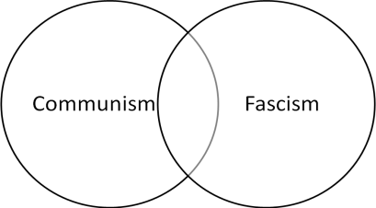Key Concept: Master Race, Holocaust/Genocide, Appeasement

**Post-WWII Era:**

What individuals/groups of individuals would you associate with the Cold War Era?

Connect the League of Nations to the United Nations

Connect the Great Leap Forward to the Cultural Revolution

Identify problems among newly independent countries

Key Concepts: Cold War, Perestroika, Glasnost, Hinduism, Islam, Satyagraha, Warsaw Pact, NATO

Key Events: Building of the Berlin Wall, end of the Cold War

**Important People and Terms**

John Locke

Thomas Hobbes

Robespierre & the Reign of Terror

Napoleon

Congress of Vienna

Factors of Production

Zionism and Israel  
Karl Marx & Adam Smith

Otto von Bismarck

Methods & Motives of Imperialism

Jewel of the Crown

Suez Canal

Berlin Conference

Franz Ferdinand

Treaty of Versailles

Joseph Stalin’s Purges

Gandhi & Satyagraha

Mao & Cultural Revolution & Great Leap

Cold War

League of Nations and United Nations

Perestroika and glasnost

Deng’s 4 Modernizations